**Physics 3A/3B**

**Particle Waves and Quanta**

**Test 1**



Time allowed: max 50 min

Answer all questions on the paper provided

To achieve full marks, clear, logical

workings and diagrams MUST be shown.

Answers should be evaluated with an

appropriate number of significant figures.

**Section A: 7 questions worth 20 marks**

1. Three students are using a piece of string to make a standing wave. The following graph shows the wavelength of part of the string at one particular instance.

Examine the graph and determine the waves:

Amplitude ______________________________

Wavelength ____________________________ **(2 marks)**

1. If the wave in the graph for question (1) is travelling at 4.00 ms-1, what is the period of the wave?

**(3 marks)**

1. 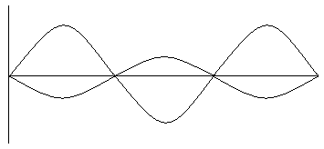A student has set up two waves on a dual beam Cathode Ray Oscilloscope (CRO). The waves are shown below. On the same axes, draw in the resultant wave.

**(2 marks)**

1. Using the space below, complete the following diagrams for **reflection** of waves at a harbour wall and the **refraction** of the sound of a bell as it enters the air from the water.

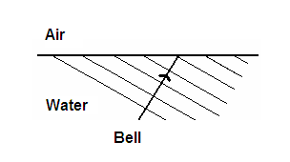

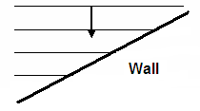

**(3 marks)**

1. Matt was running his finger around the top of a wine glass. He then increases the speed until it sounds a note. Explain why the glass sounds the note and what is the name given to this phenomenon?

**(3 marks)**

1. With the aid of diagrams and calculations determine the length of a tube, which is closed at one end, required to produce a fundamental frequency of 256 Hz?

**(3 marks)**

1. The two speakers below are producing a 680 Hz note. Assume the speed of sound in air is 340 ms-1. Point P is 10.00 m from speaker A and 12.75 m from speaker B.

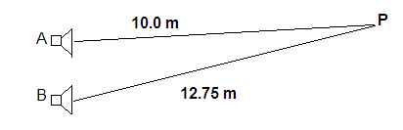

Determine if there is a node or anti-node at point P and describe what would be heard at this point.

* You must justify your answer to receive any marks.
* You may use the diagram to assist your answer and assume that the wave position next to each speaker starts as an anti-node.

` **(4 marks)**

**Section B: 1 questions worth 10 marks**

A Catholic Priest by the name of Marin Mersenne was credited with have discovered the laws of stretched strings. He discovered the following relationship:

$$f=\frac{1\sqrt{T}}{2L\sqrt{u}}$$

F = frequency (Hz)

L = length (m)

T = tension (N)

μ = mass per unit length

The following data was collected using a fixed string and a frequency generator. The tension was achieved by hanging masses on the end of the string. Masses were added to the string and the frequency adjusted until the first harmonic was observed. The following data was collected.

Length of string – 64 cm

|  |  |
| --- | --- |
| Tension N | Frequency Hz |
| 5.00 | 256 |
| 6.00 | 288 |
| 9.00 | 320 |
| 10.0 | 341 |
| 12.0 | 384 |
| 14.0 | 427 |
| 18.0 | 480 |
| 22.0 | 512 |

1. Add to the table and manipulate the date as required to allow you to plot a graph on the next page that clearly shows a linear relationship between frequency and tension.

**(4 marks)**

1. Write an expression for the relationship between frequency and tension

**(1 mark)**



**(4 marks)**

1. Using your graph, determine the value of μ.

**(2 marks)**

1. With the aid of diagrams calculate the frequency of the third harmonic for a tension of

6.00 N.

**(3 marks)**